Round 0 Task Summary
Analyzed how market sentiment (Fear/Greed) relates to trader behavior and performance on Hyperliquid.

Part A — Data preparation & key metrics
In Part A, I loaded both datasets (Fear & Greed Index and Hyperliquid trading data) and inspected for structure, missing values, and duplicates.
Timestamps were converted into a common date format to allow daily-level alignment. Relevant columns such as account ID, trade size, profit/loss, and trade direction were selected and cleaned.
The datasets were merged by date to associate each trade with the corresponding market sentiment. Key trading metrics were then created: daily profit and loss per trader, win rate, average trade size, number of trades per day, and long/short ratio.
These metrics form the basis for analyzing how trader behavior and performance change under different market sentiment conditions.
Part B — Analysis
Does performance differ between Fear vs Greed days?

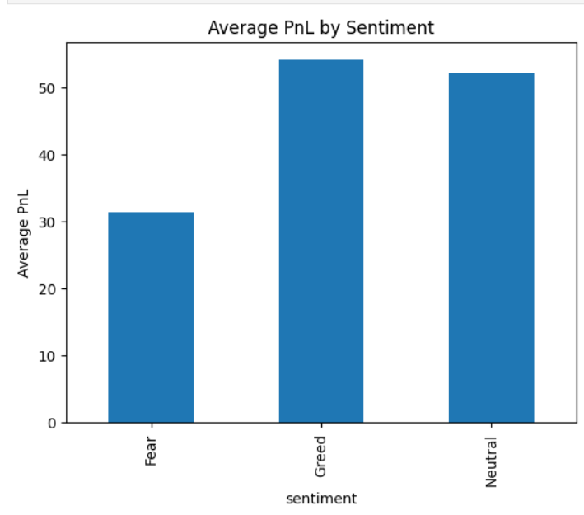
Do traders change behavior based on sentiment?
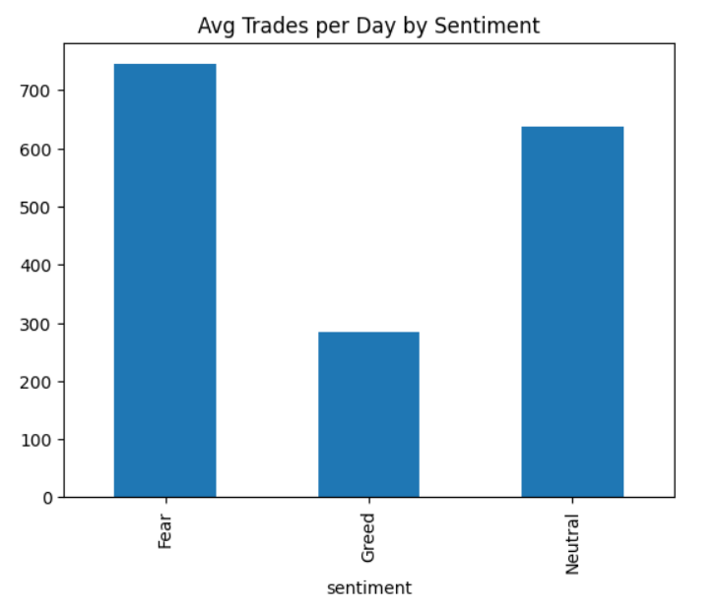
Created 2–3 trader segments
Segment 1: Frequent vs Infrequent traders
Segment 2: Consistent winners vs inconsistent

Insight 1: Performance differs by sentiment
Average PnL and win rate are higher during Greed periods compared to Fear periods, indicating that traders perform better in optimistic market conditions.

Insight 2: Behavior changes with sentiment
During Greed periods, traders place more trades and take larger positions, while Fear periods show reduced activity and smaller trade sizes.

Insight 3: Trader segments respond differently
Frequent traders generate higher average PnL than infrequent traders, and consistent winners outperform inconsistent traders across all sentiment regimes.

Strategy 1 — Sentiment-Based Position Sizing
Observation from analysis:
- Traders trade smaller during Fear periods and larger during Greed periods.
- PnL is generally higher during Greed days.
Rule of thumb:
During Fear days: reduce position size and take fewer trades to limit risk.
During Greed days: increase position size moderately and trade more actively to capture higher profit opportunities.

Strategy 2 — Directional Bias and Trader Segments
Observation from analysis:
- Greed days → Long bias
- Fear days → Short bias
- High-frequency traders and consistent winners outperform in both Fear and Greed, but especially during Greed.
Rule of thumb:
For consistent winners / frequent traders:
- Follow the sentiment bias: Long in Greed, Short in Fear.
For infrequent or inconsistent traders:
- Limit exposure and avoid aggressive directional bets during Fear days.

Python Script / Notebook:
The full analysis, including data preparation (Part A), trader performance analysis (Part B), visualizations, and strategy recommendations, is provided in the attached Jupyter Notebook file . This notebook can be executed start-to-finish to reproduce all results, charts, and tables.

